Logging and debugging for the sake of the PROJECT

• Debug logs (all APIs) → high volume
• Admin / audit logs → sensitive, low volume
• Booking logs → analytics (1-month aggregation)

Python API (FastAPI / Flask) ├── Debug Logs ───────────────► Cloud Logging ─► Cloud Storage (Blob) ├── Admin Audit Logs ─────────► Cloud Logging ─► Cloud Storage (Blob) ├── Booking Event Logs ───────► BigQuery (Analytics) └── Monthly Analytics Job ────► BigQuery (Aggregated table)

FastAPI ->
├── Middleware → Debug Logs → S3 / GCS
├── Admin Actions → admin_audit_logs (SQLite / Postgres)
├── Booking Events → booking_event_logs (SQLite)
└── Monthly Job → booking_analytics_monthly

Use -> pip install google-cloud-logging

For Debug logs and Admin logs :
1. Make a save everything directly over the GCP instance.
2. ROUTING LOGS TO BLOB STORAGE (SINKS).
3. Everything must have read only access.
4. 4.3 Retention (cost control)
Bucket | Retention
Debug logs | 30–60 days
Admin logs | 1–3 years

- Create Cloud Storage buckets -> for the admin logs for structured data logging.
- These control the routing of logs. Sinks allow you to route logs from your project to destinations like log buckets, Pub/Sub, BigQuery, or Cloud Storage, often for compliance, long-term retention, or analysis.
For booking data :
SQLite (HOT, 0–30 days)
│
├── Real-time app logic
├── Daily / on-demand analytics
│
└── Scheduled Job (30+ days)
├── Archive to Blob / BigQuery
└── Mark as archived

Run daily (not monthly) — this is important.
Daily check for the month old data and just remove from the sqlite db and just archive it in the DB.
3.1 What the job does
For rows older than 30 days:
- Read from SQLite
- Write to cold storage
- Mark rows as archived (or delete)

Example crom job on the sqlite server :
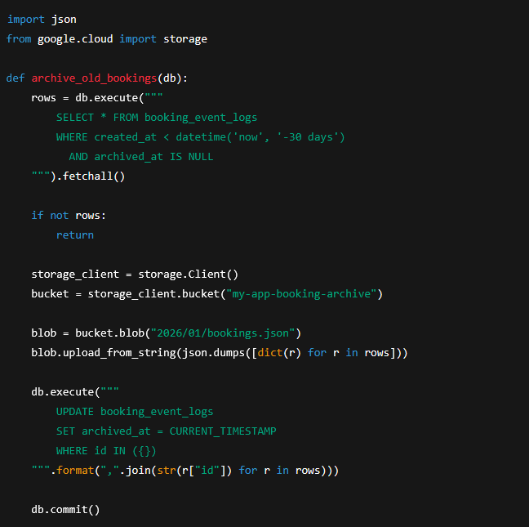
https://docs.cloud.google.com/logging/docs/setup/python -> documentation

Prompts :
- I have an application having 3 roles admin users supervisor I have all the apis ready for this application and want to make a logging system for this applications having admin logs booking logs and DEBUG logs of all the api I also want to save this somewhere and with this booking logs I want to have made analytics of past 1 month and later log it to a DB somewhere How can I achive this
- Design DB schemas -> I already have bookings details and cancellations made saved in a local sqlite db Give middleware code examples Suggest AWS/GCP-based setup Help you pick tools for your exact language (Node, Java, Python, etc.) -> IN python proceed save it to a blob somewhere foe security save admin and Debug logs
- what if I store all the booking data in the local db for first 30 days cause I only want the analytics for the past 30 days after that I can setup a job to log this 30 day old data to the db for just storage purposes
s

